Launch: Big Rivers Kahoot Quiz
Landing: Arthog River Severn Trip

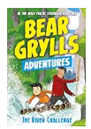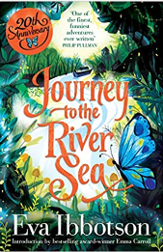

The Big questions…
Literacy
Text
The River Challenge by Bear Grylls
Journey to the River by Eva Ibbotson
Genres
Poetry: River Metaphor Poems
Narrative: Adventures (To entertain)

Science:
States of Matter
What are the properties of a solid, liquid and gas?
To identify and compare the properties of a solid liquid and gas
Do all types of chocolate melt at the same rate?
Observe that some materials change state when they are heated
How do materials change state?
Identify how temperature changes can cause changes in state
What is evaporation?
Investigate the temperature at which water evaporates-do all liquids evaporate?
What is Condensation?
Investigate how a gas turns back into a liquid
What is The Water Cycle?
Identify the part played by evaporation and condensation in the water cycle and associate the rate of evaporation with temperature

Geography
To investigate places
-Present water features of the local area
What rivers are local to us?
- Use maps, atlases, globes and digital computer mapping to locate rivers
What rivers are in the UK?
Can you name and locate significant rivers around the world?
To communicate geographically – describe and understand key aspects of rivers:
What are the features of a river?
Can you identify the similarities and differences in erosion and deposition in rivers and on the coast?

RE
The Vine and Branches -Prophecy and Promise
-The Prophet of Elijah
-Elijah on Mount Carmel
-John the Baptist
-Advent
-The Ancestry of Jesus
-Joseph the Foster Father of Jesus

Art
To take inspiration from the greats
Can you replicate some of the techniques used by Claude Monet?
Can you create original pieces that are influenced by studying Claude Monet?

To master techniques
How can brush techniques produce different texture, patterns and lines?
Can you mix colours effectively?

LFL

Get Up

The Sacraments

We don’t have to be the same

Respecting our bodies
Computing
Programming A – Repetition in shapes
PE
Hockey
Dance
Music
Sing Up Music – Year 4: The Pink Panther theme

